ا The University of Bucharest

University of mathematics and Informatics

hadeeeel

Software Project Management

Application:University Student Portal

contents

1. Business case

1.Project name: University Student Portal

2. objectives

3. motivation

4. Summary

4.1. Description The summary of product / service4.1

4.2. Description General solution proposed

4.3. Description General implementation plan proposed

5. Details of the proposed solution

5.1. SWOT analysis ( Strength , Weakness , Opportunities , Threats )

5.2. Who do the same? (The market)

5.3. comparison with other solutions, advantages + disadvantages

5.4. Possible acquisitions: observations about provider (Portfolio, support

integration)

5.5. Technologies used: compatibility with hardware / software company

5.7. Possible risks: identification, qualitative analysis / quantities, response

plans

5.6. integration with other projects / operations of the company (if

applicable)

5.7 Possible risks: identification, qualitative analysis / quantities, response plans

6- project impact

6.1 positive + negative influences on the organization

6.2 which requires changes in the organization (temporary halt of activity, etc)

6.3 benefits

7- costs

7.1 categories of cost + estimates

7.2 cost / benefit analysis (ROI, "payback period")

Part II - Project Planning  
The structure of this part is given below. V. and Chapter 3 of the book "Software Project Management "for explanation and examples:  
<http://highered.mcgrawhill.com/sites/dl/free/9780077122/700264/SPM_C03.pdf>

1 Identify project scope and objectives techniques  
1.1 Identify Objectives and Measures of Effectiveness in Meeting Them  
1.2 Project Authority has established  
1.3 Identify stakeholders Modify

1.4 Objectives in the light of stakeholder analysis Established

1.5 Methods of communication with all parties

2 Identify project's infrastructure Between

2.1 establishe relationship and strategic planning project  
2.2 Identify installation Standards and Procedures  
2.3 Identify project team organization

3 Analyse project Characteristics  
3.1 Distinguish the project would either objective or product driven Analyze project 3.2 Other Characteristics  
3.3 Identify high-level project Risks  
3.4 Take into account user Requirements Concerning Implementation Select

3.5 overall lifecycle approach  
3.6 Review Overall resource Estimates

4 Identify project products and activities  
4.1 Identify and describe project products (Including quality criteria)  
4.2 Document Flows generic product  
4.3 Recognize product instances  
4.4 Produce ideal network activity  
4.5 Modify ideal to take into account Need for stages and checkpoints

5 Estimate effort for each activity  
5.1 Carry out bottom up Estimates (i.e. Efforts estimated for each activity, the then add Obtain Them to the effort for the whole project how many person months (town days / weeks) is Necessary to complete the project)

6 activity Identify Risks  
6.1 Identify and quantify activity based Risks  
6.2 risk reduction plan and contingency measures The WHERE APPROPRIATE  
Estimates and 6.3 Adjust crying to take account of Risks

7 allocate resources  
7.1 Identify and allocate resources  
7.2 Also Includes a Gantt diagram (required!)

Part III - code management (versioning control)

Use a management tool of code to simulate 3-4 programmers working 10 File making some changes (eg from operations commit). The aim is to demonstrate the work with  
code (without actually schedule).

I - Business case

1. Project name: University Student Portal

2. The purpose application (Goals)

*StudentProjectManagementPortal_MT2010036_MT2010112_SoftwareRequirementsSpecification

*<http://www.projects.staffs.ac.uk/suniwe/project/aimsandobjectives.html>

aims at developing a centralized portal for educational institutions for managing student projects and To implement and evaluate the student portal infrastructure as a way of managing the delivery of flexible lifelong learning To improve the learner experience by providing easy access to a personalised collection of essential information, applications and electronic resources .To enable the learner to log in once to access all the information, applications and resources .To provide a foundation for tracking flexible student learning plans across institutions .To enable learner interaction in business processes such as learner data reconciliation .To implement a service-oriented approach to integrate the enterprise applications in each consortium to provide dynamic data via web services .To improve enrolment operations between student record systems and VLEs via services.

يهدف إلى تطوير بوابة مركزية للمؤسسات التعليمية لإدارة المشاريع الطلابية وتنفيذ وتقييم البنية التحتية لبوابة الطالب كوسيلة لإدارة تقديم التعلم مدى الحياة مرن لتحسين تجربة التعلم من خلال توفير سهولة الوصول إلى مجموعة شخصية من المعلومات الأساسية، التطبيقات والموارد الإلكترونية. لتمكين المتعلم من تسجيل الدخول مرة واحدة للوصول إلى كافة المعلومات والتطبيقات والموارد. لتوفير أساس لتتبع الطالب مرونة الخطط عبر المؤسسات. لتمكين التفاعل المتعلم في العمليات التجارية مثل المصالحة البيانات المتعلم. لتعلم تنفيذ نهج خدمة المنحى لدمج تطبيقات المؤسسات في كل كونسورتيوم لتقديم البيانات الديناميكية عبر خدمات شبكة الإنترنت. لتحسين عمليات انتساب بين الأنظمة سجل الطالب وبيئات التعلم عبر الخدمات.

3- motivation:

motivation of this project is to implement a website for students for sharing Information exchange between teacher and student and between the student and another student. This application will be useful for every student to get updated to latest information and communicate with other students. This process of sharing information is innovative concept mainly this application will be helpful in sharing project related information in the process of implementing final year project.

الدافع لهذا المشروع هو تنفيذ موقع على شبكة الانترنت للطلاب لتبادل تبادل المعلومات بين المعلم والطالب وبين الطالب وطالب آخر. سيكون هذا التطبيق مفيد لكل طالب للحصول على تحديث إلى أحدث المعلومات والتواصل مع الطلاب الآخرين. هذه عملية تبادل المعلومات هي مفهوم مبتكر أساسا هذا التطبيق سوف تكون مفيدة في مشروع تقاسم المعلومات ذات الصلة في عملية تنفيذ مشروع السنة النهائية.

4- Summary:

4.1. Description The summary of product / service

*2002LDPStudentPortal4444ProjectFINALReport.docx

A student web portal would allow students to access online campus services, websites, and course information from one convenient location, using a single user ID and password. They would be able to customize the portal to their own liking, adding or deleting links to internal websites, internal news channels aimed at particular groups of students, and external information such as sports, weather, entertainment, etc.

The central goal is to transform the day-to-day operations of the University by reducing paperwork; putting more information services and transactions online; and streamlining access to course information and content. A student web portal would collect these campus services and functions into a single website, making it easy for students to find and use online services, and thus increasing the likelihood that the University can attain the strategic goals laid out A tab-based user interface provides the greatest flexibility for users and developers. Tabs allow students to toggle quickly between different types of information. As more online content becomes available over time, it is a simple matter for developers to add new tabs to accommodate and organize the new content. Allowing students to create and name some or all of the tabs on their personal portal pages wound give them the maximum flexibility in choosing how to organize information to suit their own needs.

من شأن البوابة الإلكترونية الطالب تسمح للطلاب للوصول إلى الخدمات عبر الإنترنت الحرم الجامعي، والمواقع، والمعلومات بالطبع من مكان واحد، وذلك باستخدام هوية المستخدم وكلمة مرور. فإنها تكون قادرة على تخصيص المدخل لأهوائهم، إضافة أو حذف روابط لمواقع الداخلية، القنوات الإخبارية الداخلية التي تستهدف مجموعات معينة من الطلاب، والمعلومات الخارجية مثل الرياضة، والطقس، والترفيه، الخ

الهدف المركزي هو تحويل عمليات يوما بعد يوم للجامعة عن طريق تقليل الأعمال الورقية. وضع المزيد من خدمات المعلومات والمعاملات على الانترنت. وتبسيط الحصول على المعلومات الدراسية والمحتوى. ومن شأن البوابة الإلكترونية طالب بجمع هذه الخدمات الحرم الجامعي والوظائف في موقع واحد، مما يجعل من السهل للطلاب لإيجاد واستخدام الخدمات عبر الإنترنت، ومما يزيد من احتمال أن الجامعة يمكن تحقيق الأهداف الاستراتيجية التي وضعت وتوفر واجهة المستخدم المعتمدة على علامة التبويب أكبر قدر من المرونة للمستخدمين والمطورين. علامات تسمح للطلاب للتبديل بسرعة بين أنواع مختلفة من المعلومات. كما يصبح أكثر المحتوى عبر الإنترنت متاحة على مر الزمن، بل هو مسألة بسيطة للمطورين لإضافة علامات تبويب جديدة لاستيعاب وتنظيم محتوى جديد. مما يسمح للطلاب لخلق وتسمية بعض أو كافة علامات التبويب في صفحات البوابة الشخصية الجرح منحهم أقصى قدر من المرونة في اختيار كيفية تنظيم المعلومات لتناسب احتياجاتهم الخاصة.

4.2. Description General solution proposed

*Gcu-portal-doc-160128180259.pdf

*<http://www.slideshare.net/Bilal_Mubeen/documentation-of-online-student-portal?qid=97cec315-54e8-4cd4-925d-4924e7316c08&v=&b=&from_search=1>

project is complete automated system. The proposed system is developed under the tool Visual Studio using Asp.net at front end and SQL Server as back end data storage purpose. By using the Web pages of asp.net with some web Technologies such as (HTMl,Css,Javascript , Jquery), our project with the user and store all the data on their corresponding attached SQL tables. System Architecture

1. Software requirements:

Operating System

Window 10

Front End :

Microsoft Visual Studio 2012

Back End:

Microsoft SQL Server 2012

2: Hardware requirements:

Processor:

Pentium V500MHz or higher

Memory-RAM:

200MB or higher RAM

Memory-CACHE:

200MB or higher RAM

Hard Disk:

80GB or higher

HTTP Data

**server**

Microsoft ASP .Net

provider

client-server model

This application is modeled MVC(model -View -controller ) software architecture. Using logic models will hold information used by application (database tables). The database server is performed using Microsoft SQL Server 2012. View sites will be the basis GUI (Web pages viewed by the user). Controllers will contain the functional application that connects models and views (methods, variables, connection with other systems, etc.).

From the point of view of functional perspective, the following diagram illustrates the mvc Designee pattern of application.

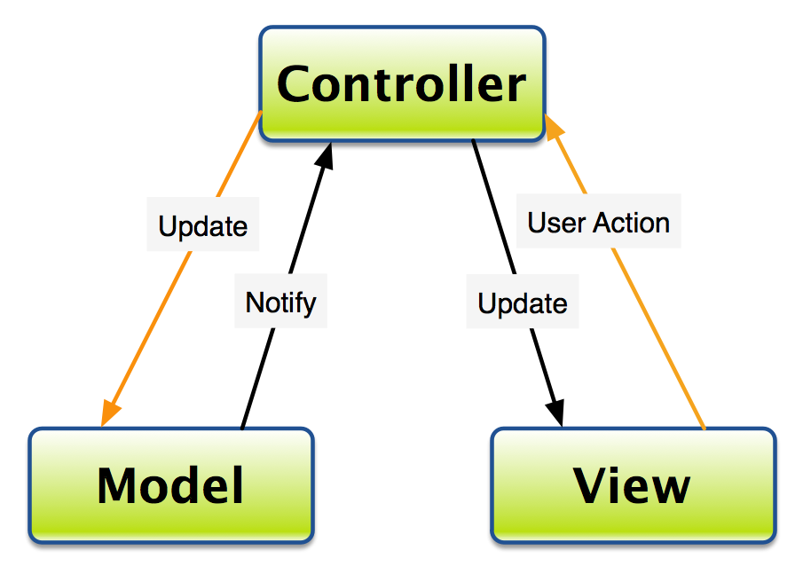

MVC software architecture

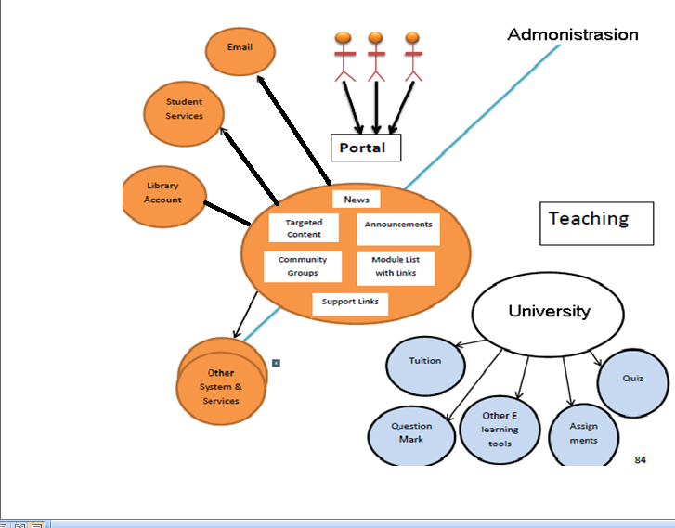

4.3. Description General implementation plan proposed

Product Functions

The final products will be

1. DBMS Host: A database will be responsible for keeping a track of Users login/ logouts. Users can be Faculty or students. The database will decide who to give the access and who not. The Database will keep a track of grading as well as their scores.

2. Online Quiz System: will allow the students to give online quiz. From university and to exceptional students to give online quiz from out of city.

3. Report Generator: would check the quiz according to the given answers given by the teacher and then will tell them the score and store it in the database.

4. Assignment Submission: assignments can be submitted on the website within time. After the given time. The submission facility will become disable. The assignment would go to the regarding teacher’s account.

5. Alerts: the interface will allow students to know about the quiz, assignments and the updates about the classes.

6. References: all the books, notes, slides will be available on the site in the specific semester folder. So that only the current student could have access

7. Video tutorials: are also going to be available on the website. There hyperlink to Vimeo, YouTube and to other links are going to be available.

Technical Description:

Portal consists of:

Students login

* Teachers login
* Students Assignments Record
* Students Quizzes Record
* News for Teachers and students
* Books for Student
* Its benefits are:
* Students can check their accounts and their marks obtained
* Teachers can upload assignments
* Reduce the complexity
* Providing interface for staff and students to communicate on a single platform

5. Details of the proposed solution

**5.1. SWOT analysis ( Strength , Weakness , Opportunities , Threats )**

* Strength:-

1. Communication Environment:-

A unique current environment-appropriate for student and teachers communication. Student can contact teacher directly. No need to share your contact number.

o Easy to use:-

No need to hire a trained staff to guide how to use to project. User manual or a person with basic IT knowledge can use it easily.

o Environment Friendly:-

Website is environment friendly. It can be opened on Internet Explorer, Firefox, Google chrome, Speed Monkey and many more.

* Weakness:

o Network Failure:-

The software is totally dependent on internet. If you are not in a hotspot area or connected to internet you won’t be able to connect the website.

o Public view:-

Trust of office on one person who manages their personal information and cross check their messages and all. Might let them feel that they got no privacy.

o User Traffic:-

User crossing the limit when connect to website will increase load on site. And cause unavailability.

* Opportunities:

o Additional Features:-

With the increase of Market demand additional features can be added.

o Better Communication:-

A student who is not in contact with friends and teacher, he won’t have to rely on anyone to tell him which quiz or assignment is coming up.

* Threats:

o Hacked:-

In the situation of being hacked your personal information and data will be accessed.

**5.2. Who do the same? (The market)**

Currently there are many websites that are just providing teachers and students to data related to their field and concern like timetable, course outline and availability of staff:

<https://uwaterloo.ca/student-portal/about>

The student portal project is led by the Student Success Office (SSO), working collaboratively with Information and Systems Technology (IST).

The portal is a mobile-friendly communications tool for current students that pulls in the UWaterloo information students need, just when they need it.

* <http://www.leeds.ac.uk/portal-project/>

The institutional portal is intended to provide a seamless, web-based interface to a range of systems and services. The portal will also offer a customized, and potentially personal sable, web environment for staff and students.

* <https://www.griffith.edu.au/information-services/publications/current-campaigns/student-portal-project>

The Student Portal Project is one of the EICP projects being undertaken by the PPO portfolio

The goal for 2016 is to provide copy and design expertise to the project group and provide communication and digital designs at key project milestones.

* <http://as.exeter.ac.uk/projects/portal/>

The new portal, called exehub, will go live in September and will give students access to all their key documents, calendars and other resources at any time, from any location, and with any device. Users of exehub will be able to create and share documents at the click of a button, and will be able to take advantage of a brand new Microsoft Office suite.

* <http://www.helwan.edu.eg/English/?page_id=237>

Suggest a number of electronic services which is offered to the students, faculty staff members and society through the universities’ portal.

Determine the minimum rate of the required data which must be available at each university’s portal and train number of workers on editing, deleting and modifying the data on the portal periodically.

**5.3. comparison with other solutions, advantages + disadvantages**

Comparing our project with others we would say that we are trying our best to make it efficient and effective so that other departments of university can also adopt it. For this we are using languages like HTML5 so that software would say in market for a time.

5.4. **Possible acquisitions: observations about provider (Portfolio, support integration)**

The application can be presented in meetings anterpenorilor pursuing start-ups and want to invest (eg Connect Hub).

**5.5. Technologies used: compatibility with hardware / software company**

<https://en.wikipedia.org/wiki/GitHub>

GitHub - is a web-based Git repository hosting service. It offers all of the distributed revision control and source code management (SCM) functionality of Git as well as adding its own features. Unlike Git, which is strictly a command-line tool, GitHub provides a Web-based graphical interface and desktop as well as mobile integration. It also provides access control and several collaboration features such as bug tracking, feature requests, task management, and wikis for every project.

Asana ـ is a modern web application that keeps teams in sync, a shared task list where everyone can capture, organize, track, and communicate what they are working on in service of their common goal. Rather than trying to stay organized through the tedious grind of emails and meetings, teams using Asana can move faster and do more — or even take on bigger and more interesting goals.

5.6. integration with other projects / operations of the company (if applicable)

**5.7. Possible risks: identification, qualitative analysis / quantities, response plans**

* **Methodology includes**
* **Risk identification**

It is the process of risks that may affect the project and documenting their characteristics selected. Such as stop provider of a service or the process of updating the site stopped for some days or hours needed and this iterative processes that occur in all phases of the project life cycle. During the process of risk identification, and can identify potential risk responses. These responses serve a useful input for the planning process to respond to risks. a risk that is very likely to adversely impact the schedule , drive costs up or drive quality down

* **Conducting Quantitative Risk Analysis**

The aim of quantitative risk analysis is to analyze numerically the probability of each risk occurring and its consequence on project objectives. The method for conducting quantitative risk analysis is twofold:

Firstly, data gathering occurs. A variety of tools and techniques are used to gather information that is then processed using the quantitative risk analysis tools. Next, quantitative risk analysis tools are used to assess risks against the project objectives.

These tools include

Interviewing

public review

decision tree analysis

sensitivity analysis

modeling and simulation

* **The Risk Response Plan:**

Information from the qualitative risk analysis is added to the risk identification template to deliver the risk response plan. The risk response plan is part of the project management plan and is used to track identified risks and the analysis. The information added to the risk response plan, in addition to the identified risks, includes

relative rating or priority list of project risks , which classifies risks according to

their individual significance a separate list can be done for each objective

risk categorization , which helps identify common causes of risk or areas that require attention .

list of risks requiring an urgent response

list of risks for additional analysis and response

watch list of low priority risks

trends in qualitative risk analysis results

6- project impact

6.1 **positive + negative influences on the organization**

**positive** ,You may each college - each section - all faculty members update the content of the site without reference to the management of the gateway project independently and under his responsibility, nor take the publishing process in this case only a few sec.

**negative** , When any college - section - faculty members wants to add any features to the project he must return to the project management.

6.2 **which requires changes in the organization (temporary halt of activity, etc)**

. codes Departments faculty .

· codes Academic programs and disciplines sections in college .

· codes College faculty members divided into sections and disciplines.

· Faculty files, which files you will turn to the pages.

· Study programs (list of each discipline) undergraduate.

· Study programs (list of each discipline) for post-graduate studies.

· Developments faculty also includes quality projects.

· Research projects altogether.

6.3 **benefits**

. Showing provide biographical official statements.  
· Allow viewing a particular site for each faculty member is managed by himself and has a free hand in its preparation and organization.  
· The opportunity to download lectures - exams models - issues and questions and send them to students solutions.  
· Providing access to scientific degrees enrollment requests (diploma -almajstar -acanutourah).  
· Show looking at their exam schedule.  
· Show looking at their exam results.  
· View courses prepared by the E-Learning Center on the portal.  
· View news conferences and workshops.

7. Cost

The amount of time it took to develop these portals ranged from five days to one year. The number of staff involved varied from two to 45 people. Funding levels also varied widely, from less than $100,000 to $2.5 million. There was no correlation between level of funding and the length of time it took to complete the project. However, there was a direct correlation between the level of satisfaction with the portal and the length of time the portal had been in production.

We did find some common experiences. All institutions report that the technical management of the portal resides in an information technology unit. All believe that high-level executive support was key to the success of their portal development project.

The portal doesn’t have to be expensive. However, it does need support at the highest level of administration, and it needs steady and ongoing funding throughout its life. Content providers (both staff and faculty) need training, consultation, and acknowledgment and reward for doing their jobs in new ways.

تراوح مقدار الوقت الذي استغرق لتطوير هذه البوابات من خمسة أيام إلى سنة واحدة. عدد الموظفين تشارك متنوعة من اثنين إلى 45 شخصا. تفاوتت مستويات التمويل أيضا على نطاق واسع، من أقل من 100،000 $ إلى 2.5 مليون $. لم يكن هناك ارتباط بين مستوى التمويل وطول الوقت الذي استغرقه لإنجاز المشروع. ومع ذلك، كان هناك علاقة مباشرة بين مستوى الرضا عن المدخل وطول الوقت قد البوابة كان في الإنتاج.

نجد بعض التجارب المشتركة. وتفيد جميع المؤسسات أن الإدارة التقنية لبوابة تكمن في وحدة تكنولوجيا المعلومات. جميعا نؤمن بأن الدعم التنفيذي رفيع المستوى هو المفتاح لنجاح مشروع تطوير بوابة بهم.

لم يقم البوابة إلى أن تكون مكلفة. ومع ذلك، فإنه بحاجة إلى دعم على أعلى مستوى الإدارة، وأنها تحتاج إلى تمويل ثابت ومستمر طوال حياته. موفري المحتوى (كل من الموظفين وأعضاء هيئة التدريس) بحاجة إلى التدريب، والاستشارات، والاعتراف ومكافأة على فعل وظائفهم بطرق جديدة.

7.1

7.2